**Step1: The PC show you “the third-party INF does not contain digital signature information”. Don’t worry, pls refer to step 2.**

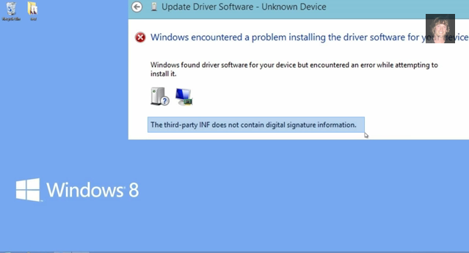

**Step2: Move your mouse to the lower right corner ,find the “setting “ in your PC. And click it.**



**Step3: After click the “setting”, you will see the screen like following:**



**Step4: Click the “Power”, then you will see the screen like following:**



**Step5: Press Shift in the keyboard in your PC and click on Restart**

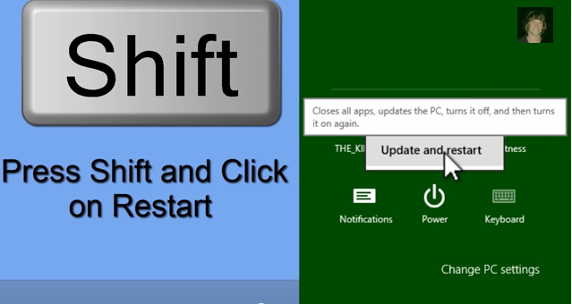

**Then your PC will be restart, don’t worry, it is normal.**

**You will see a screen like the following show:**

**Step6: Click the “Troubleshoot”**

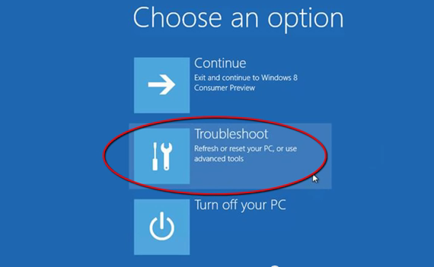

**Step7: Then you will see this screen like following, pls click the “Advanced options”**

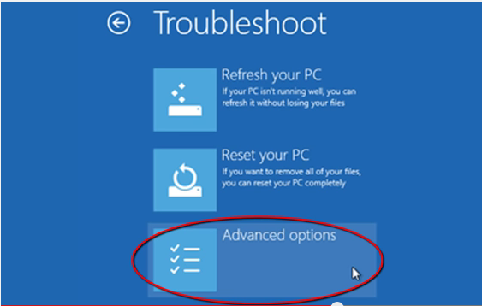

**Step8: Then clip the “Startup Settings”**

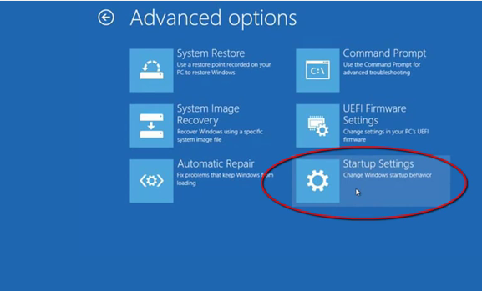

**Step9: You will see this screen, then clip the ”Restart”**

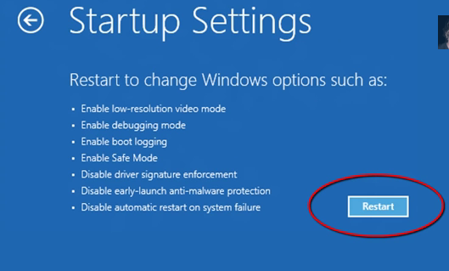

**Step10: Then you will see the following in your screen, the NO.7 show you “Disable driver signature enforcement”.**

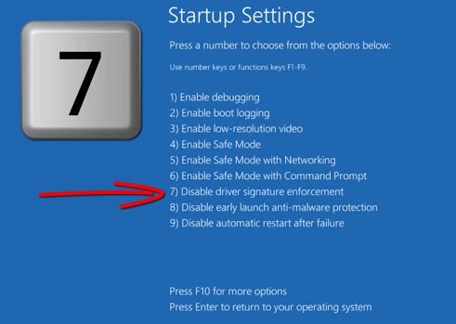

**Step11: When you see the step 10, the operation finish. Then next you could install the driver, when it occur the same screen like this, just click the “skip” to continue. Then you could refer to the doc ”software instruction” to install driver continuely.**

